**Deploy VPC components to create private EC2 instance in AWS cloud**

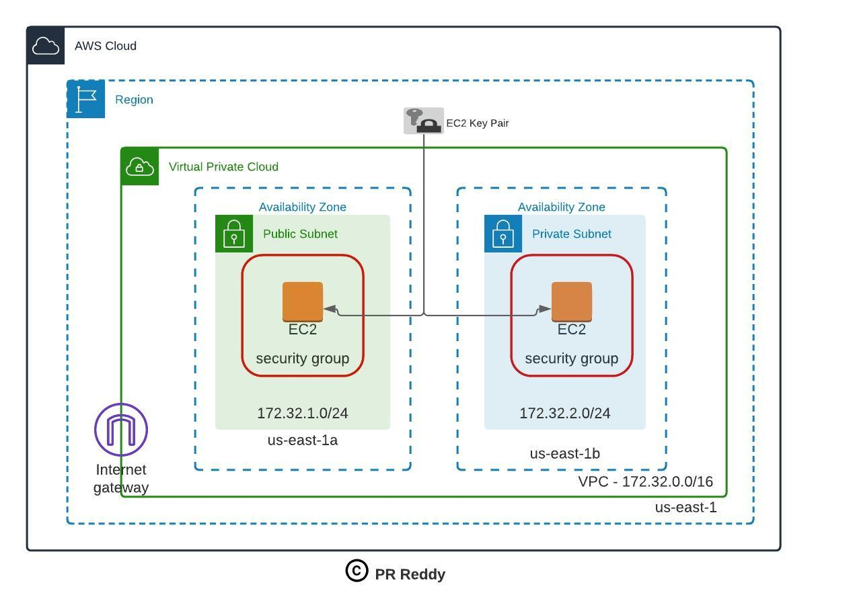

**Deployment:**

Please create private EC2 instance with "t2.micro" type in AWS cloud and the required dependency resources to connect to the private EC2 server as per the architecture shown above.

**Verification:**  
Login to AWS EC2 instance deployed into Private Subnet.

1. **Create a VPC with CIDR range 172.32.0.0/16**
   1. Search VPC, create VPC
   2. Give name-tag
   3. IPv4 (172.32.0.0/16)
   4. Click on Create VPC
2. **Create 2 Subnets ( One for public and another one for private)**

**2.1** Click on subnets, refresh it, new create VPC will shows,select it.

**2.2** Create Subnet

**2.3** VPC ID ,Select new create VPC

**2.4** Subnet setting, subnet-name:demo-public-subnet-01, Availability zone select any.

**2.5** subnet range 172.32.1.0/24 and click on create subnet.

**2.6** Create Subnet

**2.7** VPC ID ,Select new create VPC

**2.8** Subnet setting, subnet-name:demo-private-subnet-02, Availability zone select any.

**2.9** subnet range 172.32.2.0/24 and click on create subnet.

1. **Create 2 Route tables (By default you get one route table. Create one more for private subnet)**

**3.1** Click on Route table

**3.2** Create Route Table, Name: demo-private-route_table-02, VPC: new one

**3.3** Click on create Route Table

**3.4** Edit name other Route Table as demo-public-route_table-01

1. **Add Internet Gateway to public route table**

**4.1** Click on Internet gateways

**4.2** Create Internet gateway ,Name tag: demo-internet-gateway

**4.3** Click on Internet gateway

**4.4** Select the new Internet gateway ,goto Actions, Attach to VPC

**4.5** Select new VPC, click on attach Internet gateway

**(Note:** For One VPC we need allocate one Internet gateway)

**5. How to Change Private Route to Public Route**

**5.1** Goto the Route Table, select demo-public-route_table

**5.2** Select the routes, click edit routes, add route select 0.0.0.0/0 ,target: Internet gateway, click save changes

* 1. Select demo-public-route_table ,click on subnet associations, select edit subnet associations
  2. Click on demo-public-subnet-01 click on save changes

5.5 Select demo-private-route_table ,click on subnet associations, select edit subnet associations

* 1. Click on demo-private-subnet-02 click on save changes  
     **Note**: Instance provisioned under public subnet which route table is connected internet gateway is called public EC2 instance and Instance provisioned under private subnet which route table is not connected internet gateway is called private EC2 instance.

1. **Provision an EC2 instance on Each Subnet**

**6.1** Goto EC2, create EC2 instance under network select new VPC and in subnet select demo-public, launch the instance

**6.2** Create EC2 instance under network select new VPC and in subnet select demo-Private, launch the instance

1. **Assign Elastic IP and Connect to public** **EC2 instance**

**7.1** Goto the Elastic IPs

**7.2** Click on allocate Elastic IP Address, click on allocate

**7.3** Goto Actions,select associate Elastic IP address,click on public server

**7.4** Click on associate

**Note : in VPC always we need to use private ip address**

1. **Copy keypair onto public EC2 instance and connect to private EC2 instance**.

**8**.**1** To connect private server from public server

**8**.**2** ssh ec2-user@(we need to give private server ip address)

**8**.**3** To get keypair (cat > pemfile name) ex: cat > demo_key.pem

Copy the keypair and enter

**8.4**  chmod 400 demo_key.pem

**8.5** ssh ec2-user@(we need to give private server ip address) –I demo_key.pem